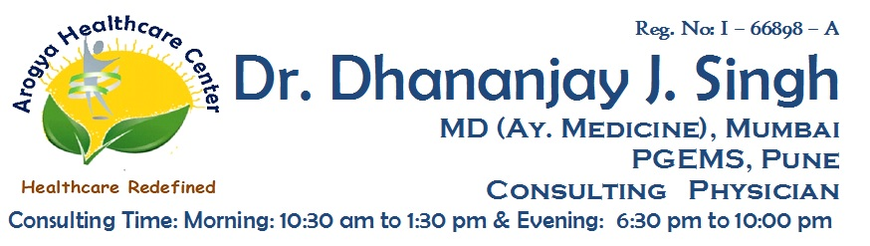

**Reg No: I-66898-A**

**Dr. Dhananjay J. Singh**

**MD (MEDICINE AY.) MUMBAI, PGEMS CONSULTING PHYSICIAN**

Date : / /2020

**MEDICAL CERTIFICATE**

**To Whomsoever It May Concern**

I have examined **Mrs. Saroj Nechand Haria**. age **66 years / Female**.

She did not have any major surgical illness. She is hemodynamically stable.

She has absence of any cognitive disorder or psychological disorder.

She is mentally & physically fit for giving consent.

**Dr. Dhananjay J. Singh**

**Address :** Shop No:3, Redwood Building, Orchid Residency, Charnipada, Bhiwandi, Dist - Thane